Indicate the answer choice that best completes the statement or answers the question.
- A rectangular inflatable swimming pool is yards long, 2 yards wide, and yard tall. What is the volume of the pool? Round to the nearest tenth. a.
b.
d.
c.
- What is the surface area of the rectangular prism below?
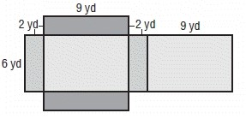
a.
b.
c.
d.
Find the volume of each figure. Round to the nearest tenth if necessary.
3.
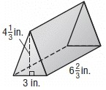
a.
b.
c.
d.
4.
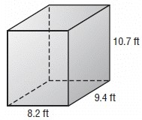
a.
b.
c.
d.
- A storage container is in the shape of a rectangular prism. The container has a length of 5 feet, a width of 9 feet, and a height of 8 feet. What is the surface area of the container? a.
b.
d.
c.
- What is the surface area of the triangular prism?
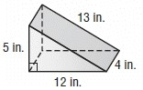
a.
b.
c.
d.
- What is the volume of the prism?
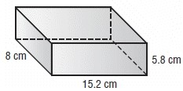
a.
b.
c.
d.
- A department store wraps gifts for its customers. What is the amount of wrapping paper it would take to wrap a gift box with a width of 12 inches, a height of 4 inches, and a length of 16 inches? a.
b.
d.
c.
- A triangular prism has the dimensions shown below. What is the volume of the prism? Round to the nearest tenth if necessary.
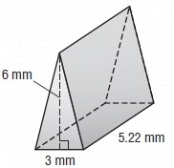
a.
b.
c.
d.
- A paperweight in the shape of a square pyramid has a side length of 2.7 inches. The slant height is 2.5 inches. What is the surface area of the paper weight? a.
b.
d.
c.
- What is the surface area of the triangular prism?
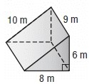
a.
b.
c.
d.
- What is the surface area of the square pyramid?
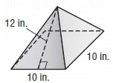
a.
b.
c.
d.
Answer Key
- a
- d
- b
- a
- b
- b
- d
- b
- c
- c
- c
- c

